November NEWSLETTER 2019
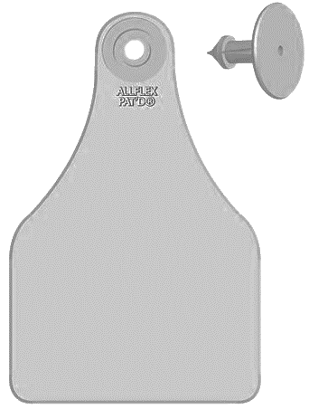
Whew! Do you feel a little like you’ve been in a whirlwind? To say that this past fall harvest season was one for the record books might be an understatement. We sincerely hope that you were able to get your feed harvested or secured, your crops off, and throughout have kept your sanity intact! As if we’d been watching an end series playoff game tied in the third with seconds to go, we’ve been on the edge of our seats cheering and hoping for you as you knocked down one acre after another. One of the magnetic signs through town states: “to those who work in acres and not hours we salute you”; we wholeheartedly agree! Now to get those cows home—the auction mart sales have had some sharp looking calves so far and we’ve seen many excellent calf crops successfully weaned on our travels these past few weeks. If you are keeping calves to background for any length of time, steers or heifers, protect that investment with a sound vaccination and deworming protocol. This weather has been up and down and can quickly become stressful on calves. Choosing the least stressful time and way to wean is important. Preventative strategies are paramount to avoid production-robbing bouts of pneumonia or other calf problems. Purchasing calves to feed? Have a chat with us to ensure a sound health plan is in place along with treatment strategies should issues arise. Recently, while we race around the country-side pregnancy testing cows we’ve come to realize that we should have a “cow-tag hall of fame.” There are some in every herd—the famous cows, the ones with unique names and unique stories—usually good for a smile (or a string of well put together profanities—at least for that &*$#! that always jumps or that cow that’s never been preg-tested). The names! There should also be special mention for the creativity in naming cows—not just the 4H pets. We’ve met Gretzky, Jackie Robinson, Oprah, Margaret and Pierre, names we cannot mention, and oh so many more. We even caught our own Jackie yodeling the cow tag numbers one day—try to hear this in your mind: eight-ele-van, eight-ele-van…eighteleveneighteleveneightele-v-an! Well—not her calling but we hope it made you smile!
Jackie
Robinson
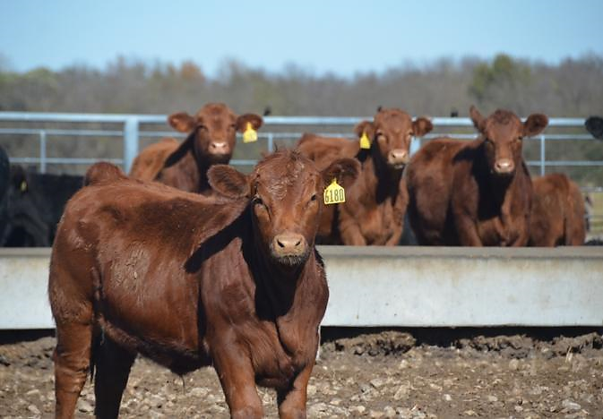
Annex R: The Canadian Program for Certifying Freedom from Growth Enhancing Products (GEPs) for the Export of Beef to the European Union (EU)—Alive and Thriving!
Calves sold under the Annex R GEP free program must be certified before leaving the birth premise of origin. If you are interested in this program please feel free to contact Dr. Dobinson. Calves must be sold directly from certified premise to certified premise so video sale is a great option (our local guys here at Stettler Auction Mart can help you with that) and keeps you open to competitive bids. Certification can be done following sale of the calves so listing your calves as eligible for the program should be sufficient to attract buyer interest for this program. Direct sales are also a good option. Calves must have at minimum an RFID tag (already required for sale), be age verified, and must have not been exposed to growth-enhancing products such as implants. While the program manual is very detailed, the program is quite easy to comply with and may be an opportunity to add value to calves in operations that already choose not to use growth enhancing products. We currently have two veterinarians certified to administer this program under the Canadian Food Inspection Agency (CFIA)—Dr.’s Dobinson and Laniak—don’t hesitate to give them a call.

Vet Client Patient Relationship (VCPR)—why we need to come out sometimes…
While many have adjusted to the not so new regulatory updates for prescribing and dispensing antimicrobial, antibiotic, or modified live vaccines we still navigate many requests for product where the VCPR is either not in place or in a bit of a grey zone. It can be frustrating to have a vet out for a quick overview of your production system, typical animal inventories and product needs. We encourage everyone to combine this discussion while we are out to preg-test or out for any other reasons. It does not need to be a separate visit. For processing protocols and routine prescriptions, we can get creative in using technology to support our medical records such as texted video or pictures of cattle, horses, or small ruminants. The AbVMA however does not feel that “telemedicine” (how they reference the use of technology to view animals) can completely satisfy the requirements of a VCPR—though policy continues to evolve. We wanted to provide a reference to the current definition of a VCPR and why you’ll still hear us encourage our required visit to your farm to establish a herd/flock relationship.
A VCPR is defined as a relationship that exists according to the following:
- The veterinarian has assumed the responsibility for making clinical judgments regarding the health of the animal(s) and the need for medical treatment, and the client has agreed to follow the veterinarian’s instructions.
- The veterinarian has sufficient knowledge of the animal(s) to initiate at least a general or preliminary diagnosis of the medical condition of the animal(s). This means that the veterinarian has recently seen and is personally acquainted with the keeping and care of the animal(s) by virtue of an examination or the animal(s) or by medically appropriate and timely visits to the premises where the animal(s) are kept.
- The veterinarian is readily available for follow-up evaluation, or has arranged for emergency coverage, in the event of adverse reactions or failure of the treatment regimen. (Canadian Veterinary Medical Association)

Our goal is to meet your needs for products and services in a timely manner and to the best of our ability while keeping compliant with our governing bodies. We will certainly make every effort to keep continued access to products you need in your production system and we appreciate your willingness to work with us in ensuring a valid VCPR is maintained. If you’re receiving our newsletter it is very likely that you have a VCPR with us and we thank you for your confidence in our services!
The Importance of Deworming Our Companions and Four-Legged Farm Hands
Many pet owners will be familiar with tapeworms and understand that “deworming” their dogs is important in keeping them healthy. Echinococcus multilocularis is a tapeworm that can infect both canines as well as humans. The adult parasites live in the intestines of a canine host (dogs, foxes, coyotes) and their eggs are passed in faeces. Typically, rodents ingest the eggs which then hatch in the rodent intestines. Larvae migrate to the liver of the rodent where they cause fatal lesions. Dogs become infected by eating the rodents. If humans ingest the eggs accidentally, they can be at risk for developing Alveolar Echinococcosis (a potentially life-threatening condition), where cystic lesions develop in various organs (commonly the liver).
Humans can become infected by eating food contaminated with eggs (such as fruits and vegetables), handling contaminated soil (especially important for children playing outside and not washing their hands), and by handing animal faeces.
Echinococcus multilocularis has been detected more frequently in the Edmonton and Calgary areas recently. Once a human is infected, it can take five to fifteen years before any symptoms appear. Symptoms in humans include weight loss, abdominal pain, malaise, and liver failure. Liver lesions are diagnosed by ultrasound, CT, and/or MRI. Dogs typically show no symptoms, so faecal flotations are useful to help your veterinarian determine if your pet has tapeworms.
Prevention in our pets involves cleaning up animal waste, monitoring your dog to prevent them from eating rodents or other animals’ faeces, and routine worming of your pet. Prevention steps for humans involves washing your hands thoroughly with soap and water after handling animals, pets, and their waste; teaching children the importance of proper hand washing; washing fruits and vegetables prior to consumption; washing your hands after handling soil or gardening; and promptly cleaning up pet waste.
Feel free to stop in and have a chat with one of our veterinarians regarding an appropriate worming product for your dog(s); it’s important to keep our companion and working dogs healthy and running in tip-top condition!

Time your Scour Vaccinations
It hardly seems fair to start preparing for next calving season, but the time is already upon us to start thinking about your scour vaccination strategy. Three products are available and with similar coverage have only a difference in timing of administration. New animals or herds to the program need two shots and ideally these shots are timed to be 3-4 weeks apart with the second shot being accurate for label recommendations in relation to the start of calving. This interval can be longer however such that initial shots can happen more than 4 weeks from the booster shot so combining the first shot with animals coming through the chute for preg-testing and dewormer is a good idea.
For bred heifers and new herd arrivals, or herds that are wanting to implement a scour vaccination program for the first time, initial shots can be given any time now to help avoid extra trips through the chute later. The timing of the booster (2nd) shot will depend on the product chosen: Scourguard 4KC will be 3-4 weeks pre-calving, ScourBos 9 will be 8-10 weeks pre-calving, and Bovilis Guardian will be 5-6 weeks pre-calving.
Animals that had scour vaccine in previous years need only a booster and this should be in accordance with label recommendations (as above). If you’re wanting to change product lines (or forced to due to a product shortage—fingers crossed that doesn’t happen again!)—give us a call to discuss the best plan for your herd situation. Not all herds need a scour vaccine program.

Clinic News
Thank you Stettler for choosing us for the Eco-Excellence award. We feel very undeserving yet very privileged to receive the award. Also, a huge congratulations to all the other award recipients at the Stettler Board of Trade Business and Citizenship Awards Gala—there are so many great businesses in our community! Terra made an awesome pumpkin carving for the Heartland Youth Big Brothers and Big Sisters Gourd-eous Pumpkin Carving contest—there were so many amazing entries—way to go Stettler! Cheryl, Athena, Alicia, and Brittany had a great time at the annual CanWest veterinary conference and Mirjam and Tara very much enjoyed learning at the Young-Bovine Practitioners conference hosted by the Western Canadian Association for Bovine Practitioners (a sad Jackie was too old to go—we’ll call that the wisdom and grey hair of experience lol!). We encourage all to take a moment of silence in remembrance of our veterans this month and we are truly thankful for the freedom we enjoy because of those whom have gone before us. Thank you!

Calling Long Distance? Use our toll-free number 1-888-GET VETS (1-888-438-8387)
Barb Munholland, DVM, Jackie Dobinson, DVM
Associates Cheryl Malin, DVM, Tara Snow, DVM, Mirjam Stigter, DVM, Alycia Laniak, DVM
Michelle Hymers, RVT, Helene Neale, RVT, Melissa Whelpton, RVT, Athena Peters, RVT,
Andrea Muhlbach, Joanne Halseth, Terra Heier, VPM, Brittany Strandquist, Vanessa Kuziw, VMA
Check us out online at www.stettlervetclinic.com and on Facebook

