****­­­­­­­­ March NEWSLETTER 2019**

***“March”ing Through…***

March is upon us and after slugging through February we can say at the very least each day is one day closer to spring! So much has been happening in, and around, the clinic and we find ourselves again marching through some changes. We have made the official change to our new business hours, of Monday through Friday 8:30am to 5:00pm, with continued full 24/7 after hours emergency services. Our goal is to allow enhanced focus on weekend emergencies with less juggling of scheduled appointments; which had been the case at times during Saturday office hours. Dr.’s Josh Relf and Yasmin Abdalla have officially completed their two year Canadian work VISA’s here at Stettler Vet Clinic and are making final preparations for their big move to Scotland. It seems that time has flown far too fast that we are already bidding them farewell and while excited for their next adventures, we are also sad to see them leave. For our three new veterinarians gearing up to arrive this spring they have certainly left some big shoes to fill. Our staff had a fantastic time at the annual Heartland Youth Center’s Bowl for Kids fundraiser as the ‘Three (plus) Blind Mice’. Check your herd bulls for frostbite! Area bull sales are well underway and year after year we are continually impressed with the quality offerings right here in our backyard—we hope you get a chance to select some excellent herd sires or top replacement heifers!



Calf Yoga- Sternal Recumbency ASAP!!

|  |  |  |
| --- | --- | --- |
| **VIGOUR Scoring System – Helping Calves Get the Best Start** | | |
| ***V*** | VISUAL APPEARANCE | A yellow-orange discolouration signals distress during birth. A swollen tongue and nose means too much time stuck in the birth canal. Watch for fractured limbs from birthing trauma or a clumsy mom. |
| ***I*** | INITIATION OF MOVEMENT | Calves should right themselves within 1-3 minutes and be sitting up in sternal recumbency within 10 minutes. |
| ***G*** | GENERAL RESPONSIVENESS | Calves should sneeze when poked with a straw in the nose and shake their head. Clear fluids from mouth and nose with a clean hand or towel. |
| ***O*** | OXYGENATION | The gums and tissues around the eye should be pink – any other colour is a warning sign of more severe issues. |
| ***U*** | UDDER | At least 1 liter of colostrum within 4 hours of birth followed by regular sucking or another 1 liter before 6-12 hours following birth |
| ***R*** | RATES | Normal heart rate is 150-200 beats per minute and slows to 80-120 beats per minute within 10-15 minutes of birth. Respiration rate should be 24-36 breaths per minute after about an hour. |

**Prime-Boost: Heterologous Vaccination Strategies backed by Research -Dr. Dobinson**

In many ways, both on the human and animal health sides of the coin, we have made leaps and bounds in the field of immunology encompassing vaccines, vaccine technology, and our level of understanding when it comes to the immune system. The basic concepts of vaccination and the benefits have stood the test of time while still being continuously improved and updated to reflect the current disease pressures facing production animals. Traditional vaccination principles focused on killed vaccines and focused on the benefits of immune memory such that two doses of the same vaccine approximately 3 weeks apart achieved strong humoral (antibody) immunity—still true! Intranasal vaccination was practiced but not understood in great detail as to how well or if it worked at all.

Recently, intranasal vaccine technology got a serious makeover and researchers utilized new molecular technologies to gain a much more comprehensive understanding of exactly how they worked. Onto the scene came Inforce 3 and not far after Once PMH IN. These products have been phenomenal and generally well accepted. While we’ve been using them for the past number of years a few questions remained unanswered and awaiting research to catch up so to speak in getting them answered.

New published study outcomes have shown this pertinent information:

* Intranasal vaccine works equally well in non-stressed and stressed animals
* Injectable vaccine does not work as equally well in non-stressed and stressed animals
* Intranasal vaccination followed by injectable vaccination (at least for viral antigens—i.e. Inforce 3 followed by BoviShield Gold) DOES achieve the anamnestic response (higher booster dose immunity levels)
* It is unknown whether injectable vaccination followed by intranasal can achieve the desired spikes in immunity though it is currently suspected that this is NOT the case
* Intranasal vaccine works in the face of maternal immunity (colostrum)
* Intranasal vaccinations do not cause vaccine reactions
* Intranasal vaccinations do in fact have some non-specific immune strengthening benefits

What does this mean for vaccine recommendations? Mainly that it remains important to discuss your herd vaccination strategy with your veterinarian! Individual management situations vary and best vaccination practices will be tailored to your unique situation as far as recommended products, frequency, and timing. Vaccination does continue to be an excellent tool in the toolkit for management of disease pressure in production animals and a huge contributor to reducing antimicrobial use in farm animals. Feel free to call anytime to discuss herd vaccination strategy for your operation!

[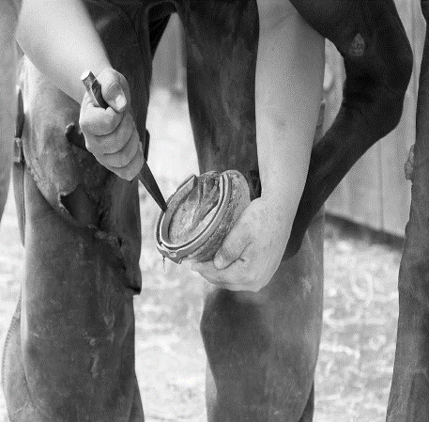](https://www.google.com/url?sa=i&rct=j&q=&esrc=s&source=images&cd=&cad=rja&uact=8&ved=2ahUKEwjH6rrAz_PgAhVR1IMKHeHHDZ0QjRx6BAgBEAU&url=https://alis.alberta.ca/occinfo/occupations-in-alberta/occupation-profiles/farrier/&psig=AOvVaw3Rtr2wyly1A9IMww6UBKT9&ust=1552171458079460)**A Step Ahead: Farrier + Veterinarian = Success -Dr. Malin**

I've always maintained that I'm a veterinarian, not a farrier and that I should work together with owners and their farriers to develop a program that will keep a horse sound for years to come. However, sometimes a farrier needs a little guidance due to functional or medical abnormalities in the feet. Recently, I attended a seminar given by Dr. Pittman, a farrier and a veterinarian from Texas. I learned so much from this seminar and I'm incredibly excited to use what I've learned to help make your horse the best horse he can be! Your farrier will still be an important part of this conversation, but now I can help them out even more. Come in to the clinic or give me a call if you have a horse that "just ain't right" or seems to have a hitch in his step.

**The “Run” Down on Scours (Excuse me sir, your calf just dropped a puddle…) -Dr. Malin**

This long stretch of cold weather has certainly had its challenges and one is the crowding of cattle. Cattle choose to stay close together and typically bed down tightly. With a smile, one client recounted how checking the cows in the day was easy—they just stand up and move while you walk through, versus night time on the really cold nights, he said he had to practically climb over them one at a time—they were in a warm spot and they just weren’t moving! Cows are bedding tightly together which increases the risk of lying on calves and creates the challenge of increased feces in small areas. We have also noticed higher stocking densities in calving barns and while out of necessity in inclement weather, it is not without similar health challenges. When there is crowding, cows teats become contaminated with feces and calves, running and bucking in the afternoon sun, end up suckling and ingesting fecal particles that can contain millions of organisms that can cause scours.

[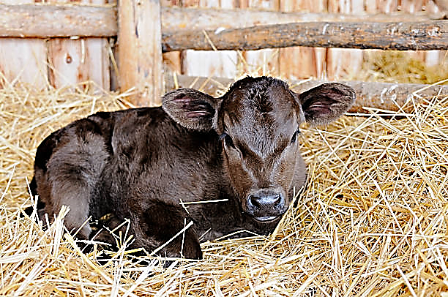](https://www.google.com/url?sa=i&rct=j&q=&esrc=s&source=images&cd=&cad=rja&uact=8&ved=2ahUKEwjqoKSZw_rgAhUh3IMKHYMmDeoQjRx6BAgBEAU&url=https%3A%2F%2Fwww.istockphoto.com%2Fphotos%2Fnewborn-calf&psig=AOvVaw2z9zkyjCXalxTqOM_CZJRI&ust=1552408424910657)Calves affected by scours may have more than one illness occurring in their body. They may not have gotten enough colostrum within the correct time period, they may have been exposed to a very high level of the offending organism, and also may have been affected by more than one virus, bacteria, or parasite contributing to scours. It is important to avoid jumping the gun by treating calves with medications that may not help, or even worse, harm them. Some medications can cause harmful side effects in young calves and should be only used in consultation with your veterinarian. Ancillary symptoms you are seeing may be due to the scouring or may be a separate issue and should be discussed with a vet. A confusing example is scouring calves that are breathing fast. This may be the start of pneumonia but also may be an increased breathing rate due to buildup of acid in the body secondary to diarrhea. Knowing the difference here is important for correct treatment.

Successful treatment of scours cases relies on swift recognition of the symptoms and accurate treatment of the calves. Hydration is key in these calves. Diarrhea quickly causes dehydration and when they are not feeling well, they often choose to stay cuddled up in the straw rather than seek out a meal from mom. This is detrimental for a few reasons: they get cold quickly without the warm milk (hypothermia), they dehydrate even further and their blood sugar levels decrease (hypoglycemia) making them weak (acidosis and hypokalemia). To keep calves hydrated you can feed supplemental milk or electrolytes if they are still nursing from the dam. In severe cases, you will need to provide all of the fluid they require throughout a day, which is a surprising amount!

Age is one of the biggest clues we have to help us diagnose what kind of organism is causing the case of scours you are seeing on farm. To be certain of the diagnosis, it can help to send away a fecal sample from a calf that has not yet been treated with medication and represents what you are seeing in the majority of your cases. This year many tested groups have come back with high levels of rotavirus infection. Scour vaccination ahead of calving helps reduce rotaviral infection and severity of clinical signs in affected calves. Management of calves and environmental pressures are also important. If you are dealing with scours or want to be prepared there are many ways we can help you minimize and manage these infections in your herd. Give us a call!

**Dear Wonderful Clients of Stettler Veterinary Clinic,**

As you may or may not have heard, we will sadly be leaving the Stettler Vet Clinic and moving to Edinburgh, Scotland. Our last day at the Stettler Veterinary Clinic was March 5th. In Edinburgh, we will be closer to family, Yasmin will pursue a PhD in Agriculture and Food Sustainability, and Josh will continue to work as a Veterinarian.

Although we are excited for what is to come, we are going to miss everyone in Stettler more than words can describe. We cannot thank all of you enough for making us feel so welcome and for giving us such an amazing experience. We have been so blessed to work with the wonderful team at the Stettler Veterinary Clinic and to have met all of you. We truly have had two incredible years here.

We hope to see you again when we come back to visit! Also, if you ever find yourself near Scotland, please get in touch! (email: [yasmin.abdalla053@gmail.com](mailto:yasmin.abdalla053@gmail.com)).

We wish you all success going forward and all the best this calving season.

* ***Yasmin and Josh***

**Calling Long Distance? Use our toll-free number 1-888-GET VETS (1-888-438-8387)**

**Barb Munholland, DVM, Jackie Dobinson, DVM, & Associates**

**Cheryl Malin, DVM (coming soon Dr.’s Snow, Thibault, and Stigter!!!)**

**Michelle Hymers, RVT, Helene Neale, RVT, Naomi Czerniak-Reay, RVT, Melissa Whelpton, RVT, Athena Peters, RVT,**

**Andrea Muhlbach, Joanne Halseth, Terra Heier, VPM, Brittany Strandquist, Kim Schipper**

***Check us out online at*** [*www.stettlervetclinic.com*](http://www.stettlervetclinic.com) ***and on Facebook***