April NEWSLETTER 2019 _
Spring
We hope that a little of the March madness is settling down for everyone—what beautiful weather we’ve had for these last few weeks of calving season. Here at the clinic we’ve been hopping—some days have been a steady pace while others have been a bit of a marathon! We are so, so appreciative of your patience and flexibility while we’ve tackled many emergencies this past month and re-routed schedules. March was the month of the prolapse—more than three times the number we’d done in years past. We have been passionate this calving season and just can’t say enough about you, our great clients! I’d also like to brag a little on our staff whom have been just as flexible and have done their absolute best to keep us organized, stocked, and on task rolling through some busy days. With the added burden of paperwork from the changes to prescribing and dispensing, our staff have done well to keep us vets on top of this particularly, as many clients are just now becoming aware of the changes—a transition for all of us! April brings thoughts of spring and we are just starting to see a tinge of green here and there. All the spring critters are back and it is hard to imagine just a few weeks and dirt will be turning out in the fields. Cheryl has some excellent spring packages on the go—a great opportunity to bundle your annual equine needs with significant savings! Bull testing continues and following the significant cold snap in winter we highly recommend testing your herd bulls ahead of breeding season. Have a wonderful Easter—we wish you both ham and turkey and the gathering of family and friends to celebrate! We wish you also many ‘April showers to bring May flowers!’

I need a bottle of…
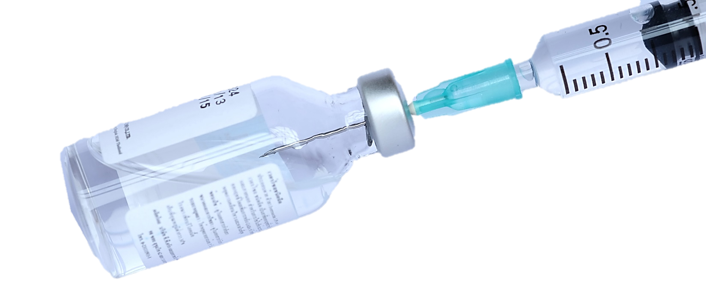
With the changes to prescribing and dispensing legislation coming into effect December 1, 2018, producers must now have a valid veterinary-client-patient-relationship (VCPR) with a veterinarian having at minimum been on their physical premises within the last year to receive a valid prescription for any antimicrobial, antibiotic, or modified live vaccine. Having an over-the-counter relationship with a veterinarian is no longer a valid VCPR for prescribing and dispensing. These requirements are federal and set out by Health Canada, our federal government, and overseen via Canadian and provincial veterinary associations. This has been a transition to say the least and while we have done our absolute best to stay ahead of these changes and keep our “business as usual” for as many of our regular clients as possible, it has led to a number of less pleasant interactions which can at times be uncomfortable. We understand your frustrations and share many of them, however are still required to abide by the changes. We also understand your timely need for prescriptions during this busy season and are doing absolutely everything we can to accommodate as many as possible! To summarize, we can fill any valid veterinary prescription—this can come from one of our veterinarians or another veterinarian from another clinic. Any prescriptions filled for another veterinarian requires us to update them with the quantity dispensed for their records as declining balances for prescriptions are required by Health Canada. Only veterinarians can prescribe and the veterinarian must have a valid VCPR with established medical reasonableness for prescribing. If you’re asking for products having had no veterinarian from any clinic attend your herd or flock, then unfortunately we are unable to prescribe for herd or flock use. In these situations, we can discuss a convenient time to have a herd visit and establish the criteria for a valid VCPR allowing us to best serve you for a production year. If you’d prefer to establish a VCPR with a different clinic or multiple clinics, you are welcome to do so and we are happy to fill valid veterinary prescriptions at any time! We hope we convey our best intentions to comply with the regulatory changes to increase oversight and diligence in stewardship of antibiotics, antimicrobials and modified live vaccines. We want to help you continue to handle the things you’ve traditionally handled alone by establishing a valid VCPR with your herd/flock, creating your annual prescriptions appropriate to your production situation, and supporting them with best practice protocols to ensure the best possible outcomes for your treatment needs. Always feel free to call or discuss your veterinary needs or concerns—we are happy to help!
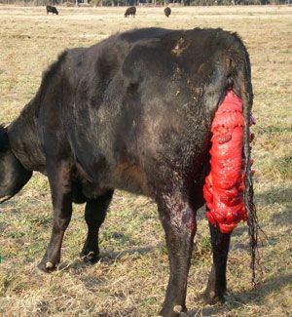
Prolapsed Uterus
A prolapse of the uterus typically follows immediately after delivery and represents a veterinary emergency. Cattle who have prolapsed are in physiological shock and must be handled with care. It is unwise and illegal to transport an animal with a uterine prolapse so the veterinarian should attend your farm for repair. Having restraint available with as little stress to the cow as possible is important. If cattle can move slowly to a maternity pen or chute, they can be gently moved near but allowed to rest until the veterinarian is close or arrived. Having plenty of water to rinse the often-dirty uterus is important and helpful. When cattle are unable to rise it is also helpful to have a few able-bodied folks and ropes to help as down repairs are best done with the cow in sternal recumbency (sitting) with her hindlegs extended out behind her (minimizes pushing and opens the pelvis for repair) and large cattle can be hard to move with limited help. Following the repair, we often try to have cattle rise so gravity can help replace the uterus to the most normal position inside. Stitches placed must stay in for 4-7 days and your veterinarian will advise of any additional treatments needed once complete. Most prolapses can be replaced and a full recovery is possible, though some cattle can become excessively shocky, hemorrhage internally, or have a stroke from a blood clot traveling to the brain following, or during, repair that can kill them. Intervention that is low stress and as timely as possible is best for this emergency! Call us right away if you see a prolapsed uterus!
Spring Packages- Now Available!
Get your horse fine-tuned this spring, choose a package that best suits your needs! Offered now until July 31, 2019.
Give us a call at the clinic to book your appointment!

Package 1  (Basic Horse) | 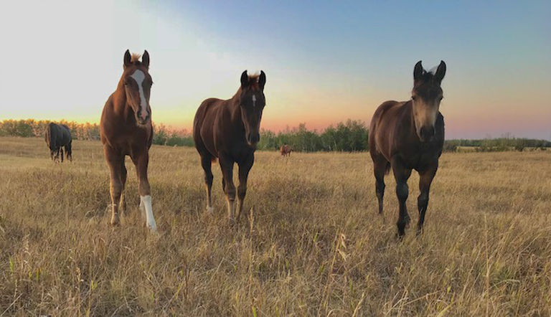  Equine Spring Packages | Package 2  (All Around Horse)
- Full Physical Exam  - Dental Exam and Float  - Sheath Clean (If Needed)  - Tube of Dewormer |  | - Full Physical Exam  - Dental Exam and Float  - Sheath Clean (If Needed)  - Fecal Egg Count  - Tube of Dewormer  - Vaccinations
Package 3  (Performance Horse) | Package 4  (Whole Year Health) | Package 5  (Geriatric Horse Health)
- Full Physical Exam  - Dental Exam and Float  - Sheath Clean (If Needed)  - Fecal Egg Count  - Tube of Dewormer  - Vaccinations  - EIA (Coggins) Test | - Full Physical Exam, Spring & Fall  - Dental Exam and Float in Spring  - Sheath Clean (If Needed)  - Fecal Egg Count in Spring  - Two Tubes of Dewormer  - Vaccinations  - Feed Testing in the Fall | - Full Physical Exam, Spring & Fall  - Dental Exam and Float, Spring & Fall  - Sheath Clean (If Needed)  - Fecal Egg Count in Spring  - Two Tubes of Dewormer  - Vaccinations

Spring To-Do List
We’re sure your ‘to-do’ list is long this time of year! Longer days seem to leave us busier and tasks can pile up suddenly. Keep in mind the following for optimal herd production.
- Spring Vaccination and Deworming:
  - Cows on a pre-breeding program should be vaccinated 4-6 weeks ahead of bull turnout. Vaccine should include Viral 5-way, Vibriosis, Leptospirosis, and Clostridial 8-way protection. If you are on a fall program this may not apply to your herd. Call if you have any questions regarding products or timing!
  - Bulls should get at least all the same vaccines as the cow herd in the spring. These boys can be agents of spreading disease while visiting multiple females each day. Fly control, deworming, and footrot vaccine can keep the boys on task!
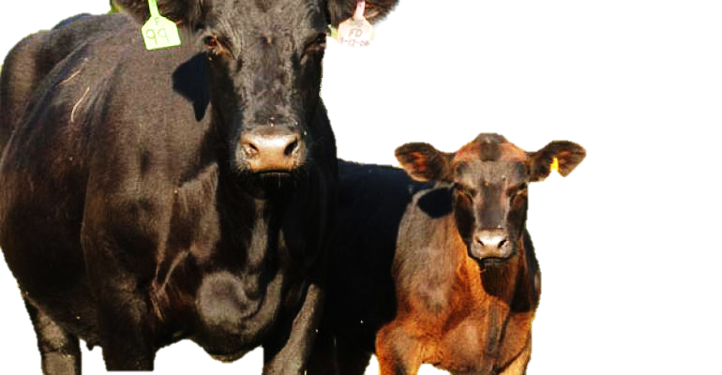
  - Open Replacement Heifers should have pre-breeding vaccinations well ahead of bull turnout (6 plus weeks if possible) to include Viral 5-way, vibriosis, leptospirosis, and clostridial 8-way. Most heifers would have been vaccinated at weaning and will not need 2 doses however heifers never-before vaccinated should have a series repeated twice 3 weeks apart. Deworming heifers can also boost conception—Safeguard is recommended.
  - Calves—vaccine recommendations can vary in herds so best to call. Intranasal protection and combination 8-way with somnugen is a recommended baseline. Parasites in suckling calves are a current research focus and deworming with Safeguard will boost pasture production! Implants are also a consideration for some herds.
- Breeding Soundness Evaluations for herd bulls and consider trichomoniasis testing for bulls over 4 years, bulls with history of reduced conception or bulls going to community pasture. After the February cold snap, most bulls are recovering but results to date show a surprising amount of stress in semen production—we recommend semen testing all herd bulls.
- Coccidiosis prevention is recommended in herds that have cases of coccidiosis on pasture. Call to discuss.
- Preg-test late cows that you are unsure about and cull unproductive females.
- Consider palpating open replacement heifers to ensure cycling, normal reproductive and pelvic anatomy, as well as identify any unwanted pregnancies that can be hard to assist on pasture.
- As cattle move out away from the yard, pile manure to take advantage of composting prior to fall when spread on fields post-harvest. Try to avoid spreading fresh manure on land to be grazed in the same year.
- Trace Mineral Boluses and Rumensin CRC (Kextone) boluses can be a growth advantage and boost conception rates in yearling grassers, replacement heifers, and second calvers.
- Yearling Grassers—consider implants and boost IBR vaccination and 8-way clostridial vaccine prior to turnout.

Calling Long Distance? Use our toll-free number 1-888-GET VETS (1-888-438-8387)
Barb Munholland, DVM, Jackie Dobinson, DVM, & Associates
Cheryl Malin, DVM (coming soon Dr.’s Snow, and Stigter!!!)
Michelle Hymers, RVT, Helene Neale, RVT, Naomi Czerniak-Reay, RVT, Melissa Whelpton, RVT, Athena Peters, RVT,
Andrea Muhlbach, Joanne Halseth, Terra Heier, VPM, Brittany Strandquist, Kim Schipper
Check us out online at www.stettlervetclinic.com and on Facebook

