November NEWSLETTER 2018
Lest We Forget
As we near Remembrance Day, it is staggering to think that this marks the 100th year since the end of World War I. During the war itself, many of Canada’s achievements on the battlefields of Europe were capped by a three month stretch of victories at the end of the war—August 8th to November 11th, 1918 that came to be known as “Canada’s Hundred Days”. Each year, school libraries set out books about the wars and this year our oldest son borrowed book after book of facts and stories about the war. We read about the war strategies, different countries roles in the wars, and how soldiers could be as young as 15 years old! We read about the tombs of the unknown soldiers in each country and how each country honors their soldiers. Book after book we just soaked it up and at times, we were overcome with emotion for what took place and what it cost. In agriculture, not that long ago, 9 out of 10 people in Canada were tied in some way to a farm and had great understanding of what farming was. Now less than 2 in 10 people have ties to agriculture and farming is completely unfamiliar to many of our youth. The same realization hits me as we celebrate the 100th anniversary of the Armistice. We will need to be intentional going forward to pass this important piece of history to our future youth. We need to tell the stories, show the pictures, and teach about the incredible sacrifice made for the freedom we have and many times take for granted. We are ever grateful, and we will remember.
While we work through November, we hope that everyone managed to get their harvest in. Preg checking and fall vaccinating is well underway and we are happy to help with all your veterinary needs as we head into winter!
Keeping Chickens Heading into Winter
As the cold weather comes around it is important to keep in mind a few basic principles if you are going to be housing chickens inside.
It is important that your coop be well lit and ventilated. Layer birds over 20 weeks old need at least 14 hours of light per day at an intensity of 30 lux. This will improve egg production and also helps prevent floor eggs as birds will be able to see their nest boxes better. Broilers require 16-18 hours of light daily to improve growth rates.
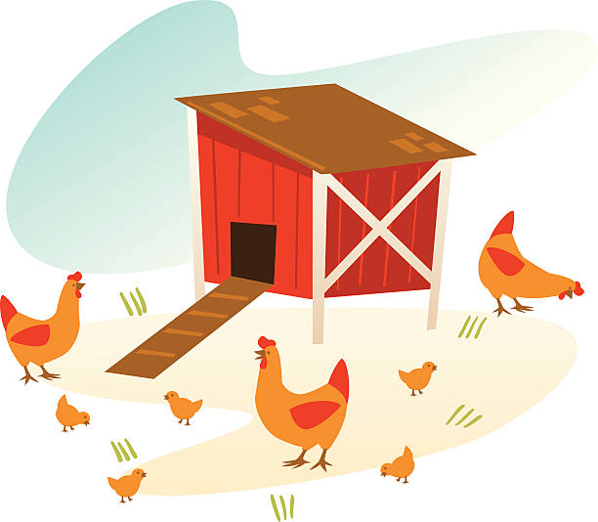
Ventilation is essential to remove ammonia and carbon dioxide from the environment and to minimize dust. Air quality should be such that ammonia is less than 25 ppm, CO2 is below 3000 ppm and humidity is between 50-60%. If the air is too dry there will be a tendency towards dust production and the dust can carry e coli in the air. If the air is too humid there will be a tendency towards wet litter which causes ammonia in the air.
Temperature control is also important to maximize productivity. Ideally a steady temperature of 21.1 degrees Celsius should be maintained.
Alongside this, it is important to maintain 5-7 cm of absorbent litter (shavings, straw, chips etc), provide a dust bath and to clean soiled litter from the coop daily.
As the birds are often more crowded indoors there is increased risk of respiratory disease and digestive disease. Signs to be watchful for in your birds are bloody/watery feces, reduced water/feed intake, huddling, gasping, sneezing, swollen eyelids, head/face swelling and misshapen or malformed eggs (this especially can be a sign of respiratory disease). If you are seeing any of these signs, give us a call and we will be able to advise you further.

Testing Feed: An Important Tool in the Toolkit
With this dry year it’s going to be more important than ever to test your forage feeds and monitor the condition of cattle to avoid sacrificing production. Some nutritionists estimate that less than 10% of producers use feed testing or nutritional advice as a herd management tool. We feel that number is low in our experience but even what we see is that many more producers can benefit from feed testing and ration formulation. Taking out the guesswork and knowing exactly what is in your feed can allow you to provide the best feed at the most critical points in your production cycle. Knowing the gaps will allow a proper mineral supplementation program that addresses any deficiencies or imbalances. Often there is money to be saved where producers have been caught over-supplementing! Cows often come off pasture in mid-gestation when forage quality is declining. Protein and energy requirements step up as cows move to late gestation, step up again for calving and lactation, and then must be maintained to support cycling into the next breeding season. Cattle should also move from a simple trace mineral salt to a full mineral pre-mix by this time of year as forage macro-mineral availability declines. As you probably know, last year there was a shortage of vitamin A. This year the supply for oral formulations seem to be good and costs are back in check to some extent. Though some countries have seen a return of injectable vitamin A, Canada doesn’t seem to be one of them, however we do have alternatives to boost cattle where needed. Bottom line is that feed testing is cheap and an important tool for decision making. With feed supplies tight and winter-feeding upon us we recommend testing and working with a nutritionist to best manage your feed. Feed tests can be submitted through the clinic and samplers are available. We can also help connect you with a nutritionist if needed. Feel free to call or stop in!
Horse Hay and Pasture Testing for the Winter
As we enter the fall and winter, the pasture grass is declining in quality and we will be needing to feed hay to our horses. In the past, we just fed it, but we now know that not all hay is the same. With the discovery of Cushing’s disease or PPID and Equine Metabolic Syndrome, we now know that many of these horses need a low-carbohydrate ration. Grass hay can have anywhere from 5-35% carbohydrates. Horses with insulin resistance need to be eating hay that is less than 10% nonstructural carbohydrates, so if you have insulin resistant horses you need to know the carbohydrate values of the hay before you buy it. Ask the seller if they’ve tested. If not, a cheap feed test is quick and takes only a couple days. If you are planning to graze through the winter, you can also test the pasture. To do this, take about 20 samples of different areas, cutting the portion of the plants the horses eat. Cut all samples into 2” segments and mix well in a plastic Ziploc bag. For bales, sample at least 10% of the bales with a core sampler and mix the samples well in a Ziploc bag. We work with Nutrylitical lab in Calgary and a quick NIR test can be done with overnight results! Core samplers are also available to use here at the clinic so feel free to call or stop by.

Some producers are planning for a long winter-feeding period. If you had to overgraze your pastures it may be a slow start to grazing next spring and that will land right in the breeding season where nutrition will drive conception rates—definitely not the time to be out of feed. Take time this fall to preg-test the herd and get all the non-productive cattle off the feed payroll. Many clients have asked how the preg-testing has been going and to be honest it seems like most years—some good some bad! You don’t know until you test, so book your herd as soon as possible.

Pyometra’s: An Important Reason to Spay Your Pets!
Chances are if you have a pet, you have heard about spaying and neutering. Bob Barker announced at the end of every Price is Right to “Have your pets spayed and neutered”. But the question is why? Spaying and neutering prevents unwanted puppies and kittens, helps to reduce certain types of cancers, and wandering to find a mate; but that’s not all!
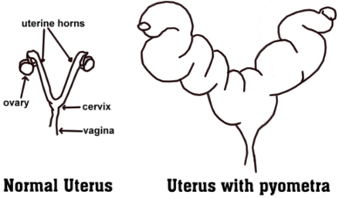
Did you know that spaying your female pets can also prevent a life-threatening illness called a Pyometra? A pyometra is when the uterus becomes infected and fills with pus. Toxins and bacteria leak from the uterus and into the bloodstream causing severe illness and can potentially lead to death. We typically see pyometras in un-spayed dogs and cats over the age of seven, who have been through a heat cycle in the last 1-2 months. Signs can be subtle to obvious, cats in particular tend to hide their illness until it is quite advanced, and most owners have no idea that their cat has been ill for a while. Typical symptoms of a pyometra present as any of the following: decreased appetite, vomiting, increase in drinking and peeing, lethargy, exercise intolerance, and a distended abdomen, with or without discharge from the vagina. When a patient presents with these signs to the clinic, we start with a thorough history, which includes a discussion about when the last observed heat cycle was. We then perform a full physical exam, and then typically recommend doing some diagnostic tests, such as bloodwork, x-rays, and ultrasound, to confirm the diagnosis of a pyometra. Bloodwork shows patterns of widespread infection, and radiographs or ultrasound show a distended uterus. Treatment for pyometra is spaying, which is the removal of the ovaries and uterus, antibiotics and pain medication. Even though the treatment sounds routine, as we perform spays numerous times per week, there is nothing routine about a pyometra spay. The surgery itself is challenging, as the uterus is swollen with pus and very fragile. There is always a risk that the uterus could rupture, spilling the infected contents into the patient’s abdomen, causing peritonitis (a serious life-threatening infection of the abdomen) and death. Even if the surgery occurs without major complication, there can still be life threatening effects post-surgery, because of the toxin, inflammatory proteins and/or bacteria that have built up in the bloodstream. Even without the uterus rupturing, the patient still may die due to complications from the disease process. Anesthesia is more of a risk in a compromised patient, and even in a healthy patient, anesthesia can be unpredictable. For these reasons the cost of an emergent pyometra spay is markedly higher than a standard spay.
Prevention of pyometras is one of the main reasons your Veterinarian will recommend spaying your pets, as it is a completely preventable but deadly disease. Unfortunately, we have seen cases like these quite frequently in the clinic this year, so we would like to encourage and remind pet owners to elect to have their female pets spayed when it is the safest and earliest time to do so. If you have questions about spaying or neutering or wish to book an appointment for either of these surgeries, please contact us at the clinic and we will be happy to assist you.
4605 – 51st Avenue Box 1120 Stettler, AB T0C 2L0

Calling Long Distance? Use our toll-free number 1-888-GET VETS (1-888-438-8387)
Barb Munholland, DVM, Jackie Dobinson, DVM, & Associates
Cheryl Malin, DVM, Josh Relf, DVM, Yasmin Abdalla, DVM,
Michelle Hymers, RVT, Helene Neale, RVT, Naomi Czerniak-Reay, RVT, Melissa Whelpton, RVT, Athena Peters, RVT
Andrea Muhlbach, Joanne Halseth, Terra Heier, VMA, Brittany Strandquist
Check us out online at www.stettlervetclinic.com and on Facebook!

403-742-3338 403-742-1170 stetvet@stetvet.com

