June NEWSLETTER 2020
Green Grass Up to your A—what!?!
What a lovely spring so far! It has been beautiful driving around to calls enjoying the gorgeous green grass and leaves covering the landscape. Ground moisture seems to be in good shape with a few good showers and a couple good soakers so far! We hope this spring your pastures will have grass up to your ass (one can wish anyway!). Many cattle are already out grazing with many bulls turned out. Cattle still in corrals are probably pressuring the gate each morning as they crunch down one more day of dry winter feed. Spring vaccinations are well underway with many done. If your cattle are out on pasture and the pens are empty—what’s left to do? We chat about pasture mineral and some tips for managing it below. Last month we wrote a reminder to watch for lead exposure on pasture and unfortunately as cattle have been hitting pastures recently we have already been alerted to a couple of exposures. Keep vigilant, watch for batteries, particularly in old junk piles, building sites, or abandoned machinery that may be left in pasture areas. Sometimes while no exposure has happened for years the battery can crack such that the lead salts are exposed. Please call immediately if you think your cattle have been exposed to lead. Biting insects are out in full force (Jackie is covered in mosquito bites already!) and beyond mosquitoes, ticks seem to be here to stay in our area (yuck!!!). External pest control is important—when riding, it keeps us safe and for cattle (bulls especially) it keeps breeding activities focused. Flies take an amazing amount of bloodmeals daily off cattle and limit production on pasture, so control is worth the cost. Back to breeding; it is also an important time of year to watch nature’s ‘discovery channel’ and make sure your bulls, stallions, rams, billies, and whatever else you’re breeding out back (what do you call a male llama or alpaca?—read on to find out) are getting the job done. Libido issues, anatomical issues, and traumatic injuries can hinder breeding and cost a lot when it comes to hindered conception. Watch your male animals closely for proper mounting and intromission during breeding, note females bred, and depending on cycle length (cows cycle every three weeks) watch for returns to heat in animals previously noted as bred. Beyond this, it’s probably time to find a shady spot with a quiet breeze and take a nap in the grass!
Pasture Mineral—some food for thought and a few do’s and don’ts
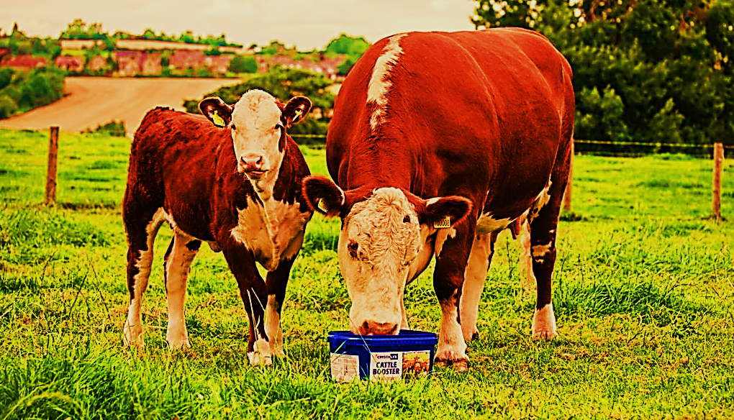
It is generally recognized that cattle should be fed mineral year-round, including during the grazing season. This varies between producers and we’ve seen everything ranging from only salttrace mineral saltfull mineral program. Many producers ask about the trace mineral concentrations in tame and native forages and whether they meet animal requirements. The short answer is they do not; level of mineral in a given forage can vary due to soil type, plant species, stage of growth, weather, and forage management. Absorption of trace minerals from the gastrointestinal tract of animals is extremely poor and, in some situations nonexistent. For example, only about 5% of copper in forages fed to mature cattle is absorbed regardless of forage source. Combine this fact with copper antagonists such as high sulphate water or high molybdenum, then copper absorption becomes essentially zero! This is a similar situation to manganese and zinc and thus why dietary requirements are set significantly higher than the actual requirement of the animal. Minerals are broken down into ‘macro’ (calcium, magnesium, phosphorus) and ‘trace’ (copper, zinc, magnesium) minerals. Mineral formulations typically provide either inorganic (chemical complexes with oxides, chlorides or sulphates) or organic (known as chelated) forms (complexed with protein, amino acids, or yeast) of each mineral whereby inorganic minerals are poorly absorbed and thus need to be fed at higher rates then chelated forms which are easily absorbed and utilized; obviously chelated mineral formulations are more expensive and thus often reserved for calving, breeding season or known deficiency situations where absorption is important.
There are many ways to provide mineral and when one looks at the multitude of choices on the market all with unique formulations it becomes a little overwhelming. Mineral can be expensive and feeding it can range from easy to impossible! Some herds overconsume mineral while others will absolutely not touch it—this often varies with the salt and phosphorus content of your forage which can vary greatly with soil types; mineral palatability also plays a roll. Typically, the need for salt and phosphorus are the two reasons a cow will seek out mineral. Understanding the mineral tag becomes important to ensure adequate intake. Two mineral supplements having 3000mg/kg versus 1000mg/kg of the trace mineral copper for example, consumed at 70grams per head per day will provide 210mg versus only 70mg per head per day. The first mineral consumed at targeted levels would meet the copper requirements of most cattle while the second mineral would likely result in copper deficiency even when consumed at the recommended daily intake, particularly if there are issues with sulfates or molybdenum in the pasture/water being fed. Failure to supplement mineral over the spring and summer grazing season will simply deplete an animals’ reserves and lead to deficiency situations. This can lead to delayed cycling and poor conception rates—not what you need!
Management of mineral feeding can be frustrating; either they eat it like candy, or you can’t get them to eat it! While targeted daily consumption will vary with each product—cattle should consume roughly 70-100grams per head per day of loose mineral and 25-30 grams per head, per day of loose salt. Blocks and tubs will vary with formulation. Poor mineral consumption can, in some cases be related to commercial flavorings, salt content, or high content of unpalatable minerals (example a 1:1 mineral has higher phosphorus and doesn’t taste as good as a 3:1 with lower phosphorus by content when fed free choice). Location of the feeder in relation to water and salt will also influence consumption. Place mineral alongside salt and move closer or further from water source to influence intake (closer to water to increase intake and further from water to decrease intake). Some minerals have salt built in and you should not feed salt separately in this case. Watch how many mineral stations or ‘opportunities’ cattle have. It is recommended to have one mineral feeder per 20-30 head. Single station feeders may hold enough mineral by weight but in a herd mentality, cattle crossing the path of the mineral only once per day may be ousted by dominant cattle and miss out. Do not put out more than a week’s worth of mineral—weather can affect mineral and cattle are less likely to eat clumped or crusted mineral; mineral companies have drastically improved weather technology but still keep an eye on this. Mineral feeders can vary from a plastic tub to much more elaborate covered systems. If you’re just starting to feed mineral on pasture, there are many do-it-yourself feeder designs that can work just as well as a $500 plus version (though these are pretty nice too!).
Lastly, we currently recommend you do not feed Rumensin or other ionophores with pasture mineral unless you have a known problem with coccidiosis. Ionophores are a tool for increased feed efficiency when used with higher carbohydrate diets. With forage-based diets however they can decrease or slow fiber breakdown by changing the dynamics of rumen fermentation. There are scenarios however depending on forage type and quality where there may be a benefit, but this is best discussed with a nutritionist and combined with feed, soil, and water results. Other additives to minerals such as insect growth regulators (IGR’s—call and ask Jackie about this) are very beneficial and can significantly decrease horn fly production losses. Biotin and Zinc can also be increased to promote hoof health. Antibiotics (specifically chlortetracycline) can be prescribed for mineral mixes to control foot rot and pinkeye in known problem areas if needed. SafeGuard oral parasite control may also be prescribed as an additive to your mineral or trace mineral salt. A solid mineral program changes with stage of production—grazing is no time to quit feeding mineral. If you have questions about mineral or need help with pasture mineral recommendations, please contact Dr. Jackie Dobinson here in clinic and she would be happy to help!
Doesn’t That Just Tick You Off??
Most veterinarians think the creepy crawly things are pretty cool and get pretty excited when you bring your ticks to town to send away for surveillance—not Dr. Dobinson though—she HATES the crawling things with a passion (yes, she will scream and dance for ticks). So, what options do we have for treating ticks and lice in horses? Unfortunately, there are no products currently labelled to repel those pests in horses. Do not fear though! We have products that can, and do, work! These products are topically applied and absorb into the skin and act to actively repel the insects. Advantix II (for dogs), BOSS (for cattle) and Cylence (for cattle) are the three products we have at our disposal that we can prescribe. The bonus is that some of these products also work to repel mosquitoes and flies!!! One catch in very occasional cases is there can be small areas of hair loss where applied and for this reason we suggest you spread the product over the body and avoid areas where your tack has contact. As each product is off label and requires a prescription as well as slightly different application techniques, come in and talk with one of our vets to determine which product would best suit your horses! For cattle there are also topical treatments that can be applied pre-pasture turnout. If you have an oiler kicking around, we do have a good supply of boss, cylence, and incide 25 and can help you with a recipe to keep the bugs off your cattle!
A look back at Calving 2020
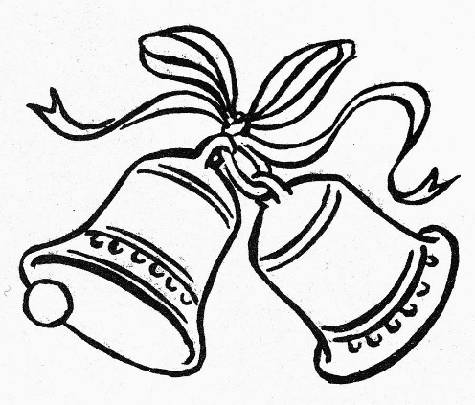
When out on farm this time of year we often ask you how your calving season went. What went well and what was challenging? Honestly, I love these conversations and am a junky for hearing how people manage their herds and tackle the problems. Some solutions are very creative and industrious! This year seemed to be a little tough on calf health with a lot of coccidiosis, some scours, and pneumonia in calves. Some folks had easier seasons while others faced a more challenging go this year. That often seems to be the case and in either situation we are happy to be available to help when needed. An older vet used to say that getting them on the ground was the easy part but keeping them alive; well that is harder! When asked how our calving season was at the clinic we often reply with more general answers and in truth it was a pretty typical year as far as what we saw and helped with. Once in awhile for fun though, we run the reports and look at what we’ve accomplished…so just for fun: We did about the same number of caesareans as last year. There was a slight decrease in prolapsed uteruses. Calvings that didn’t need a caesarean were roughly the same as last year. We had a few less calves in isolation for scours but did more on farm treatments so probably similar to last year. We did a lot more preg testing this January-February than other years which was likely more of a shifting of fall work from 2019 as harvest certainly had some challenges, though overall we preg checked more cows this fall/winter than the past five years. We did many herd health visits and saw many cattle for the regular abscess, lameness, eye issues, digestive upsets, and more and overall, did a little more of that than last year. Export work was less this year in our practice but we still did a handful of exports. What stands out the most this year is the bulls! We tested 500 more bulls than last year as of the end of May and wow—just wow! I didn’t think it was that big of a difference though I guess that explains a little why I was so tired some days. On a funnier note, I did feel like I spent the last five months living out of my vet truck—there was probably more pairs of socks in there than my dresser. I asked many times if Barb would let me buy a helicopter to save a little time (she wouldn’t, go figure) but alas at the end of all my investigating it turns out I drove a little less than last year when we looked at the mileage report—rats! One thing is for sure, between our calving season and yours, is that we all worked hard and we all got through it—great job everyone!
Clinic News: A Poem From Jackie
Cowboy Ryan long and lean, hair of brown and eyes of green…loved the cows out on his ranch and every time he got the chance—he’d call the vet out, not anyone, but would request the special one. Cause Dr. Laniak with eyes of green, of whom he’d come to be quite keen; would do the work and fix the cows till Ryan got up the courage somehow…to finally ask this special vet, if any others had popped the question yet? With rosy cheeks, a few dates, and a kiss or two; these two will finally say “I do.” A vet and a farmer or farmer and a vet? They haven’t quite decided yet. We just thought if you hadn’t heard, we’d introduce you to Mrs. Dr. Nauenberg!! Congratulations Alicia and Ryan!

Calling Long Distance? Use our toll-free number 1-888-GET VETS (1-888-438-8387)
Barb Munholland, DVM, Jackie Dobinson, DVM
Associates Cheryl Malin, DVM, Tara Snow, DVM, Mirjam Stigter, DVM, Alicia Nauenberg, DVM
Helene Neale, RVT, Melissa Whelpton, RVT, Athena Peters, RVT
Andrea Muhlbach, Joanne Halseth, Terra Heier, VPM, Brittany Strandquist, Vanessa Kuziw, VMA
Check us out online at www.stettlervetclinic.com and on Facebook

