May NEWSLETTER 2019
Welcome Snow Brings Needed Moisture
While posing a few health challenges to calves with the changes in weather, we are also very grateful for the little bits of moisture so desperately needed. After seeing some pretty big fires a little too close to home, it comes with a sigh of relief. We hope for more rain to rejuvenate stressed pastures, though, also know that some producers may have grazing challenges decreasing grazing capacity. Preg-test cows remaining to calve and cull non-productive cattle as a positive step in managing numbers. Book pre-breeding examination of open replacement heifers to catch unwanted pregnancies or reproductive abnormalities to ensure the best possible conception rates for heifers in the early breeding season. Test bulls for breeding soundness and watch closely in the early breeding season for libido, breeding ability, injuries, or other problems. Plan spring processing to be as low-stress as possible taking into consideration the weather, handling facilities, and having sufficient help. Only mix vaccines for processing when needed as they should be used completely within 1-2 hours of mixing and should be kept cool; a cooler with icepacks works well. Change needles or nasal cannulas every 10 head and only draw out product from vials with clean needles. There are many
tips and tricks to help with spring processing and a little planning helps minimize your stress too! Many herds will remain on feed for now and if your feed supplies are decreasing in quantity and quality, definitely reach out to ensure no negative impacts on production. We can point you to a nutritionist and help with feed testing to ensure your intakes are meeting the needs for this critical window of lactation and re-breeding. A little creativity and use of available resources with feeding can get you through and we can help with that. If you are seeding crops, we wish you all the best and hope you stay safe and rested this spring!
Equine Spring
Packages Underway!
Get Entered to Win an Awesome Prize Package with Every Spring Package Purchased! Call for details or to book your appointment today!
403-742-3338

Pain Management for Branding and Castration—
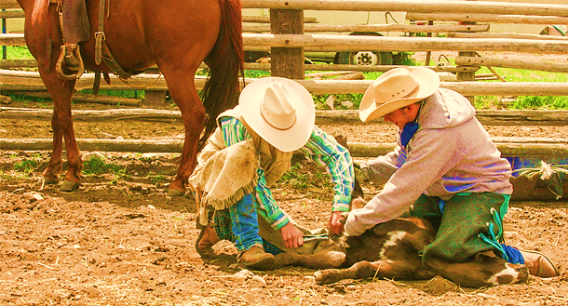
What We Think and What We Know Canada’s Code of Practice for the Care and Handling of Beef Cattle and the Alberta Farm Animal Care Beef Code of Practice are always evolving taking into consideration both the changing views of a more informed public as well as current scientific information. The results on pain control used with castration of bulls is currently recommended to include pain control in all bulls six months of age and older. Our current recommendation of best practice for castration is to be performed by banding or proper surgical castration in calves less than 7 days from birth and preferably less than 3 days from birth. When this is not done for various reasons, the next best recommendation is surgical castration at the next time the calf is handled—typically “branding” or pasture turn-out. Ideally castration is performed by an experienced person using proper, clean, well-maintained equipment, and accepted techniques. A recent study looked at two month old calves averaging 282lbs dividing calves to three treatment groups: sham brand/castrate (controls); iron branded + knife castration, and knife castration without branding. Groups were then divided into either receiving pain control with the procedure or not receiving pain control. Acute (right away) and chronic (later) pain were assessed in the study. Calves castrated and branded showed the greatest acute pain, calves castrated showed intermediate reactions, and calves not branded or castrated (still put through the tip chute and handled) showed the least pain reactions. Metacam treated calves (active ingredient meloxicam) had reduced signs of acute pain. Pain control significantly reduced signs of restlessness and time spent walking. Measurements of chronic pain however did not differ significantly between any of the treatment groups (meloxicam is eliminated from the body about 4.5 days after injection). This suggests calves younger than 6 months can still benefit from pain control at castration.
Production impacts of pain include physiological stress, decreased feed intake, and decreased resting time so getting calves back to normal as soon as possible helps minimize this. Pain control products are available by prescription and we strive to understand each individual producer’s operation, number of calves and cattle, and ensure users adequately understand proper dose and administration. Many clients report visible benefit and lots are using it even in newborn calves. Getting castration done ahead of weaning reduces mortality and morbidity (death and sickness) in the feedlot by >30% compared to calves castrated at feedlot entry. We recommend castration as early as possible and we recommend pain management in calves castrated older than 1 week of age. Please feel free to call or discuss the use of pain medication when processing your calves this spring.
After a long day on the road, the vet got back to the office to see a message from one of his calls earlier that day—calling the farmer he heard that a calf he’d castrated that morning had a swelling that kind of looked like a testicle and was in the crowding tub if the vet could stop out again. The farmer was out in the field but called the next morning to ask the vet what he’d found and if he’d missed a testicle…the vet replied, “well it was a testicle alright and that’s the first time I ever saw a calf with a third nut!”
Spring Warnings and the 5 P’s
With some relentless challenges this past winter, sparse feed supplies, and many overgrazed pastures with lingering stress from the past two years, Barry Yaremcio, beef and forage specialist with AB Agriculture and Forestry here in Stettler, predicted the following at a veterinary conference this past January:
- Many cows will be turned out to pasture too early
- Cows will have low body condition scores this spring
- High open cow rates next fall
- Poor conception rates this spring
- Calving challenges due to inadequate nutrition
- Poor forage growth and production in areas experiencing two previous years of moisture deficiency
We agree that pre-breeding nutrition is a concern for many area herds. Return to normal cycling after calving can stretch from a desired 40-60 days all the way out to 90 days and beyond with poor nutrition. Milk yield and calf gains are also adversely affected with strained nutritional conditions. Most cows nursing calves require 15 kg of hay per day or its equivalent in grain, silage, and other roughages and cow nutrient requirements increase rapidly following calving and this demand lasts for approximately 3 months.
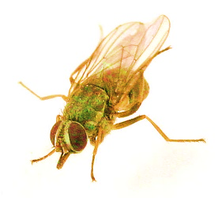
The Five P’s—proper planning prevents poor performance—govern many things in life and the cattle business is no exception. Reproductive efficiency has the greatest impact on the economic returns of a cow-calf operation—more than any other performance trait. Lack of feed intake (energy and protein) remains the most common cause of reduced reproductive performance in beef herds. Breeding activity needs to be closely monitored, especially through the first few weeks. Semen test bulls and plan for back-up bulls. Assume that cow problems will only get worse on pasture and cull eye, udder, and feet problems ahead of grazing. Consider parasite control and ionophores (such as monensin) as ways to increase feed efficiency and thus reproductive efficiency. Ensure increased mineral supplementation through the first 3 months following calving and plan for effective mineral stations on pasture. Don’t be tempted to skip vaccinations and continue herd immunization for optimal disease control. Any herd expansion in particular warrants a good look at vaccination programs. Please always feel free to call and discuss your herd needs this spring and let’s ensure proper planning for optimal performance as an ounce of prevention is always worth more than a pound of cure!

Plan for Fly Control on Pasture This Spring: What Are IGR’s & How Do They Work?
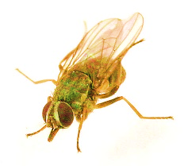
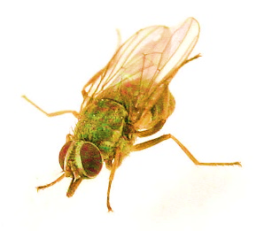
Horn flies hurt your cattle and hurt your profits. The adult horn fly is a biting insect that takes 20-40 blood meals per day. The resulting stress interrupts the grazing patterns of cattle, causing them to go off feed and expend energy in an attempt to dislodge the flies. Research shows calves from badly infested herds gain weight more slowly than un-infested calves and are lighter at weaning by 10-25 lbs. Severe infestations can also negatively impact breeding, cause and spread mastitis, and hinder milk production. Control methods in nature include predatory insects including beetles and mites which break the life cycle of eggs, larvae, and pupae. Chemical measures for control include fly tags, pour-on treatments, sprays, and feed through IGR’s. IGR stands for Insect Growth Regulator and is a feed through technology known to decrease emergence of adult flies on pasture. It works by passing though the cattle in manure and prevents development of adult stage flies from pupae. To date there are no known resistance issues to these products, they are rapidly degraded and pose no toxicological effects to environment or other species or insects, animals, or birds. Often IGR’s can be incorporated into mineral on pasture and should be considered. Use IGR’s for 30 days before emergence (when average temperatures reach 18C) through to 30 days after the first frost for best pasture fly control. IGR’s have a 17 year track record in the US and it’s good to see them finally licensed in Canada. All fly control measures are considered successful when there are less than 200 flies per cow visible. Fly control measures should start ahead of fly season and IGR’s in particular help limit emergence. Bulls at the very least should have two fly tags and a topical application of Cylence, Boss, or similar topical product at turnout to help maintain breeding focus. The cost of fly control should be thought of in terms of return on investment rather than upfront cost. We stock fly tags and pour-on fly treatments. We can also recommend a mineral with and IGR option (Rio Nutrition, Crystalx, Right Now Emerald) or direct you to a nutritionist that can incorporate it into your program.
”Circle Flies”—an officer was standing next to the farm truck writing out a ticket and batting away some flies; as he wrote the ticket he heard the farmer say “them darn circle flies are buggin’ ya.” After handing over the ticket and still batting at the flies the officer asked, “what are circle flies?” to which to farmer replied, “you know—there the ones that circle the back end of the horse!”
Clinic News
A huge welcome to Dr. Tara Snow who has arrived in Stettler joining our team! Tara will be riding with Jackie for her first few days to see the lay of the land, meet some great clients, and get her feet wet! Dr. Barb Munholland is spending a welcome week in Hawaii with the high school band students—we’re not sure how restful chaperoning teenagers will be but we are so glad she can get a little rest from what has been a very busy calving season. Four of our lovely AHT’s attended a weekend of continuing education as I write this and we are excited to hear what they’ve learned. Finally we bid an epic goodbye to the last clinic minivan (what!!!!!) and finally got Barb a new ride while she was away in Hawaii—while refusing to drive a vet truck we finally convinced her to settle for an SUV and Andrea has been busy getting it set up and ready to work. Farewell to the minivan!
Happy Mother’s Day to all the incredibly strong, loving, and wonderful mothers out there!
You are greatly appreciated!

Calling Long Distance? Use our toll-free number 1-888-GET VETS (1-888-438-8387)
Barb Munholland, DVM, Jackie Dobinson, DVM, & Associates
Cheryl Malin, DVM (coming soon Dr.’s Snow, and Stigter!!!)
Michelle Hymers, RVT, Helene Neale, RVT, Naomi Czerniak-Reay, RVT, Melissa Whelpton, RVT, Athena Peters, RVT,
Andrea Muhlbach, Joanne Halseth, Terra Heier, VPM, Brittany Strandquist, Kim Schipper, Rachael Deaver
Check us out online at www.stettlervetclinic.com and on Facebook

